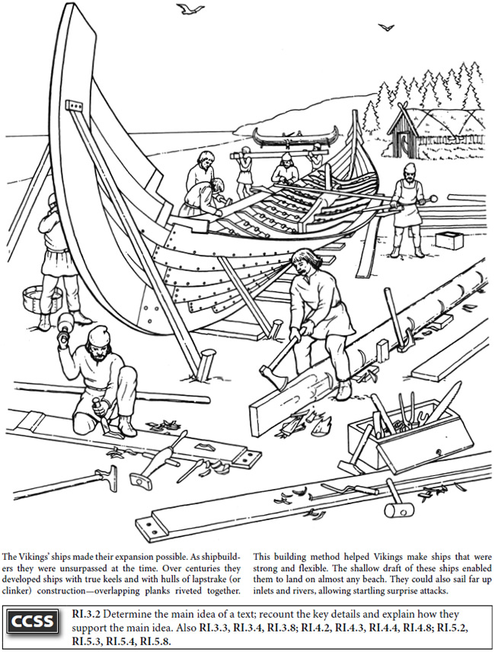
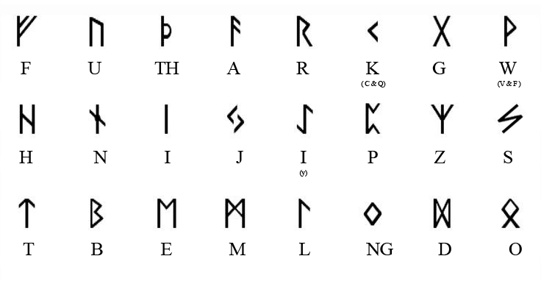
What were Nordic pirates, explorers & traders called?
W I k I Qs

_________________________________________________

What were Norse ships called? L o q s h I p s

_________________________________________________

Where did Leif Ericson go? W I n e l a n d

_________________________________________________
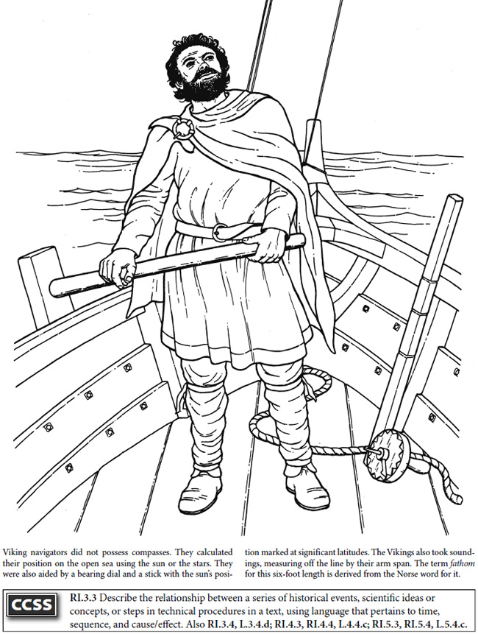
How far did west did Vikings travel? a m e r I c a

_________________________________________________

How far south did Vikings travel? a f r I k a

_________________________________________________

How far east are we sure they traveled?
c o n s t a n t I n o p l e

_________________________________________________
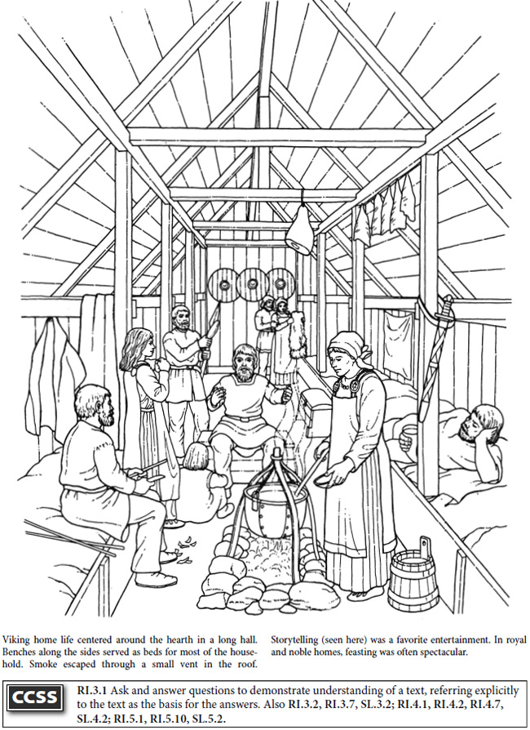
What were pots made from? S t o n e , m e t a l

_________________________________________________

How many rooms were in Norse house? o n e

_________________________________________________

What was in the center of a Norse house? f I r e

_________________________________________________

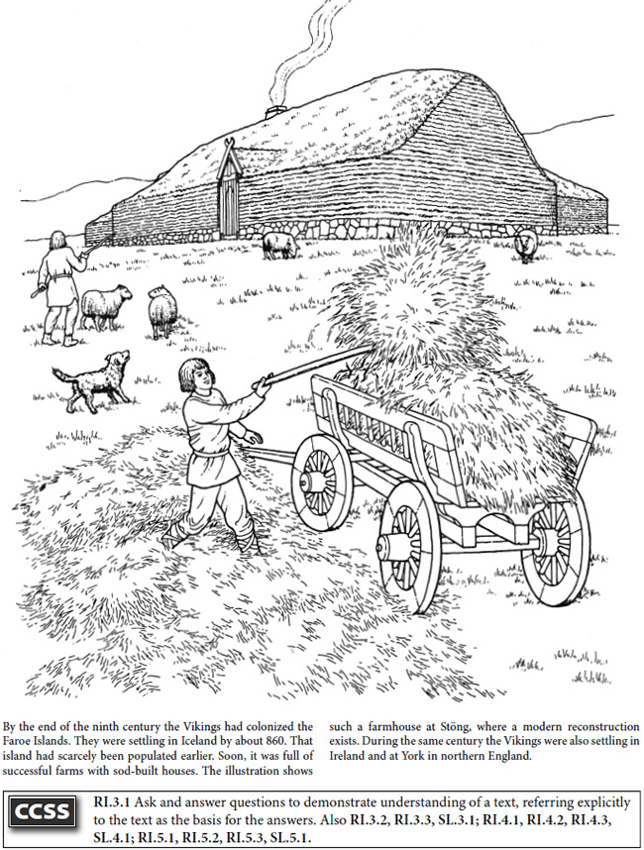
What were Norse houses called? l o q h o u s e s

_________________________________________________

What profession did most Norse have? f a r m e r

_________________________________________________

What did most Norse wear? w o o l , l I n e n

_________________________________________________

