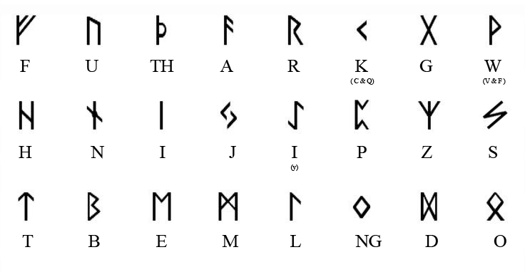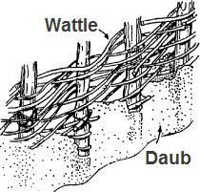
When you weave sticks to make walls or fences, what is it called?
w a t t l e

_________________________________________________

What species is used for making wattle and daub houses, and also grows nuts? h a z e l

_________________________________________________

What do you put in daub to hold make it sticky and hard? c l a y

_________________________________________________

Other than houses, what did people use wattle for?
f e n s e s

_________________________________________________
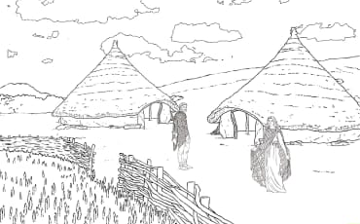
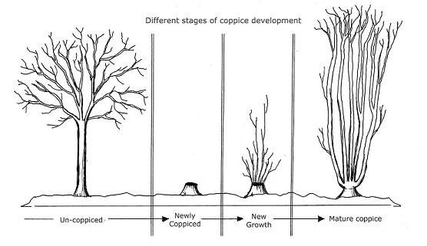
When you cut a tree at the base and it sprouts straight long branches up, what is it called? c o p p I c e

_________________________________________________

What native tree coppices well and makes tasty sap?
m a p l e

_________________________________________________

Do all species of trees coppice well?
N o

_________________________________________________

Do coppiced trees live longer or shorter? l o Q e r

_________________________________________________

